

V 1.0
June 2025
XStep Design Specification
SMPL SIP/CIP Confirm Results

Table of Contents
1 Purpose 3
2 Overview 3
3 Reasons for developing 3
4 Authorization 3
5 Assumptions/ Dependencies 3
6 Validation Checks 4
7 XStep Layout Design 4
8 Configuration Specifications 4
9 Test Scenarios 4
10 Document References 5
11 Revision History 5

Purpose
This document outlines the functional and technical design, along with the configuration specifications for the XStep SMPL: SIP/CIP Confirm Results.

Overview
The SMPL: SIP/CIP Confirm Results XStep is designed to allow operators to formally finalize and verify equipment sanitation milestones within the Electronic Batch Record (EBR) before routing assets into downstream production phases. This step provides a centralized panel where operators review physical printouts or computerized reports generated by clean-in-place (CIP) or steam-in-place (SIP) skid systems to log critical compliance data and secure raw machine records.
This process step features an instruction block followed by an integrated data entry grid, and a dedicated digital signature block.
The step contains the following main input fields:
- SIP/CIP Batch ID: This is an input text field. The operator manually enters the unique cleaning batch code or run number generated by the sanitation equipment skid into this identification container.
- Verify Passing SIP/CIP Report: This is a mandatory dropdown selection menu containing the following options: Pass, Fail, and N/A. It serves as a status evaluation tool used to formally define and record the compliance outcome of the cycle report against recipe targets.
- Expiry Date: This is an input date field. The operator logs the specific expiration date governing the validity period of the cleaning event in this field.
- Performed By: This is a digital signature field. The operator executing the sanitation verification and responsible for recording the information inputs their signature details here, applying their password credentials to lock the verification data rows.

Reasons for developing
The SMPL: SIP/CIP Confirm Results XStep was developed to centralize and automate equipment sanitation compliance tracking within the EBR. Combining manual batch tracking, dropdown status verification, expiration calculations, and automated electronic attachment uploads into a singular layout removes the risk of missing paper records. This step guarantees a completely traceable equipment preparation audit trail, ensuring that only verified, active, and fully clean processing systems are used during manufacturing operations.

Authorization
N/A

Assumptions/ Dependencies
 | Assumption
1 | Master Data has been set up correctly
2 | The process step contains a table that allows the user to capture sample data to the SAP system
3 | The user signing the signature fields is an approved user in the system with the correct access configuration
4 | The signature fields are set up with the correct dependencies that lock the applicable steps when executed

Validation Checks
Error Handling
Error | Action
Signature validation | The user is required to provide a password validating their ID before their digital signature is accepted.
Signature Strategy | A signature strategy will be implemented so that operators or/and verifiers must sign off before goods issue transactions are locked and automatically posted in SAP.
Authorization | Appropriate authorization is required for users to execute the XStep/PI sheet.

XStep Layout Design
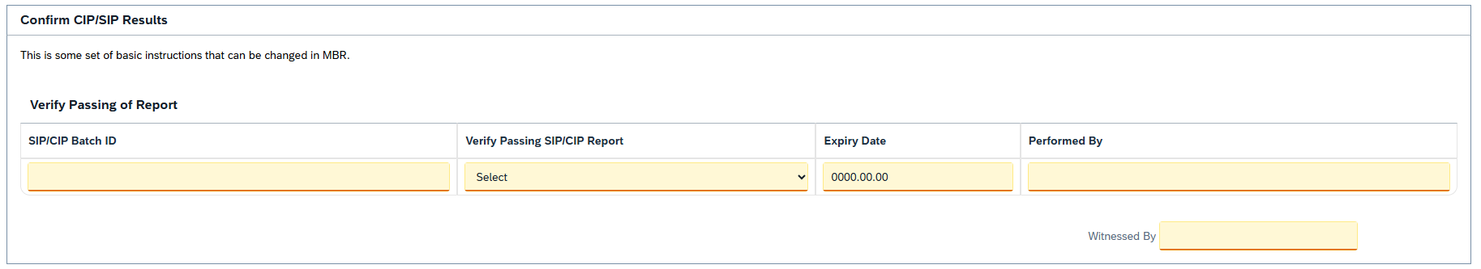

Configuration Specifications
N/A

Test Scenarios

# | Scenario | Expected Result | Actual Result | Pass/ Fail
1 | Create and Release a Process Order with the pre-configured SiMPL Master Recipe for the SIP/CIP verification setup. | Process Order is created and Released containing the new SIP/CIP Confirm Results XStep.
2 | Open the EBR, navigate to the relevant phase, and locate the verification block. | The EBR panel opens successfully without system errors, displaying the header text, instructions, and data entry grid.
3 | The operator enters the unique sanitation log number in the SIP/CIP Batch ID field. | The input value is accepted by the system.
4 | The operator selects an option from the Verify Passing SIP/CIP Report dropdown selection field. | The chosen compliance status option is accepted and displayed correctly in the field.
5 | The operator enters the specific expiration date in the Expiry Date field. | The input value is accepted by the system.
6 | The operator enters an invalid date format into the Expiry Date field. | The system displays a validation error message and blocks progress until a valid date structure is typed.
7 | The operator inputs their signature details in the Performed By signature field. | The input signature is accepted by the system, executing the signature strategy to lock, authorize, and finalize the verification data rows.

Document References
Reference No. | Document Title

Revision History
Version No. | Description | Author | Date
1.0 | Initial Document | Ruby Lutwama | 29/05/2026

